Images: Taken from google as a question. (I have written BFS for DFS graph and vice versa. Don’t go by the numbers!)

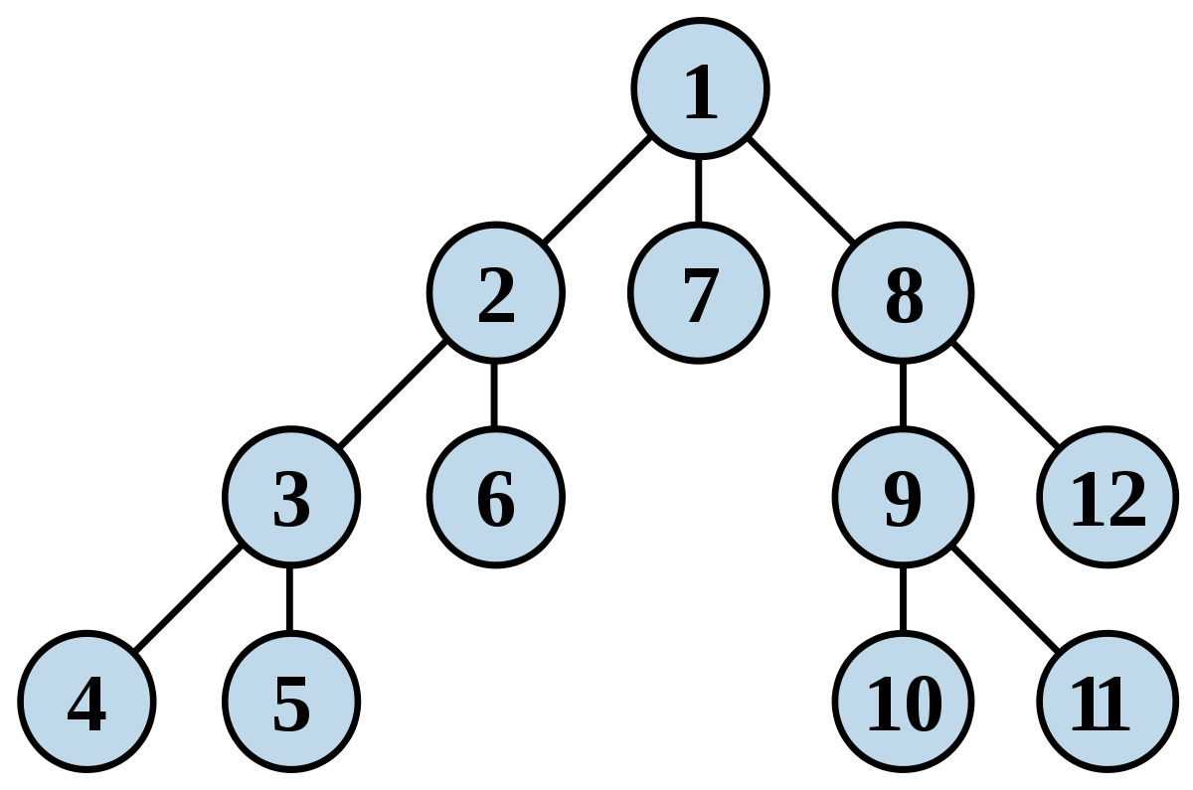

BFS: 1 2 7 8 3 6 9 12 4 5 10 11



DFS: 1 2 5 9 10 6 3 4 7 11 12 8